Kačka
FIVE FEET APART

This film tells about Stella Grant, suffering from cystic fibrosis, genetic disease, where the patient is sentenced to a lifelong, never-ending merry-go-round, thorough day-to-day examinations, personal restrictions and regular hospital checks. Because of her illness, she can only go out with her friends in a hospital where she spends all her time. Stella has her best friend Poe, who also suffers from cystic fibrosis. With whom she has been friends since she was little.
She also has an older sister Abby, who unfortunately died. Stella says she should have died, not her sister Abby. So she "can't afford to die" so her parents don't lose her.
Stella therefore closely follows everything it has, so that the treatment would stop her from getting her new lungs. Stella also filmed about her illness on YouTube, describing her illness and her life.
Stella has her favorite nurse Barb, who has been taking care of her since her childhood.
Stella likes to spend her free time watching babies in hospital incubators, where she first met Will. He also suffers from cystic fibrosis.
Their illness allows them to approach each other within a maximum of two meters, so that they do not catch anything from each other.
They fall in love and see each other more, but barb doesn't like it, because she made the same mistake once and both died.
Stella and Will will agree that Stella will help him with the treatment and he will draw her for it. And so they spend more and more time together.
In a few days Will was 18, so Stella decided to give him a celebration.
Together with poe, his mom and his friends they will hold a secret celebration in the hospital dining room. When Barb found out she sent them home and in the rooms. Another terrible thing happened that night. Poe failed the lungs and he died. Stella "collapsed" when she found out.
That night she decided to go to town, because she wanted to see the city, because when she was little with her sister they said they were "lights".
On the way out of the hospital she was going to Will and he went with her. On the way they met a frozen lake, so they glided on it. For a while the ice cracked, so they got off it. Then they sat on the bridge and talked. Meanwhile in the hospital, they said they had new lungs for Stella. When Barb went to tell her she didn't find her. So everyone was looking for them.
Will then learned that there were new lungs for her and wanted to go back, but Stella didn't. Stella then fell on the ice before Will could reach for her, the ice cracked and she fell into the water. Will managed to pull out, but she wasn't breathing, so he had to give her first aid. Before the ambulance Stella arrived for them to breathe. When they arrived at the hospital, Stella went to surgery to have new lungs. Fortunately, she didn't catch anything from Will and everything went well.
Before Stella woke up from anestessia, Will made a surprise for her. They turned on her lights all over the hospital garden, because she didn't see those in town. When Stella wakes up from her surgery, she sees Will through the glass of her room. He has setup a display of lights outside of her room, saying that his only regret was that she did not get to see the lights so he brought them to her. He tells her that his drug trial isn't working, and he doesn't want her to have to deal with his eventual death. Confessing his love for her, Will makes her close her eyes, because he says he won't be able to leave if she is looking at him. Stella closes her eyesand Will walks away. Before he left, stelle gave another gift. He gave her a book in which he painted her and also painted there everybody she liked.

Stella Grant
Stella Grand is an ordinary seventeen year old girl. But unlike most teenagers, they spend a lot of time in the hospital. Her life is full of routines, boundaries and self-control.
She goes through a tough test when she meets Will Newman, patients who suffer from the same disease.
something about her appearance: Stella is a brown-eyed and brown-haired girl, slender middle figure.
By nature she is friendly, kind and nice. She is very consistent, positiv in everything and willing to help everyone. She cares about her friends and her family. On how hard is her life she handles it quite well.
Stella says: Human touch. Our first form of communication. Safety, security, comfort, all in the gentle caress of a finger. Or the brush of lips on a soft cheek. It connects us when we're happy, bolsters us in times of fear, excites us in times of passion and love. We need that touch from the one we love, almost as much as we need air to breathe. But I never understood the importance of touch. His touch. Until I couldn't have it. So if you're watching this, and you're able, touch him. Touch her. Life's too short to waste a second.

own opinion and interesting facts about the film
I liked this movie very much. Is very interesting and you can see how difficult it is for people to get sick. it's a very sad movie.
I even cried at it. Like when Poe died or when Will left.
Five Feet Apart is an American romantic drama from 2019 directed by Justin Baldoni and screenplays by Mikki Daughtry and Tobias Iaconis. The film was inspired by the true story of Dalton and Katie, who were diagnosed with cystic fibrosis. Starring Haley Lu Richardson and Cole Sprouse.

own dictionary

until – dokud
ordinary – obyčejný
suffer – trpět
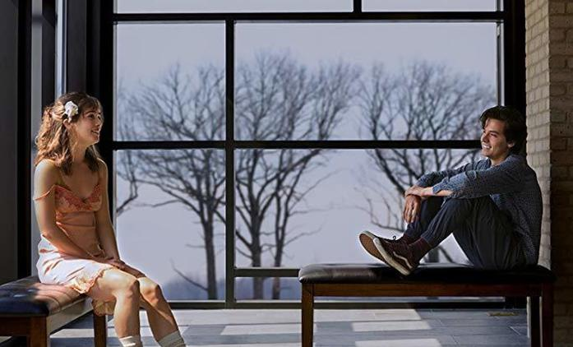
decided – rozhodla
sumery – chirurgická operace
closely – úzce
apart – od sebe/odděleně
examinations – vyšetření
unfortunately – bohužel
treatment - léčba

